**Sprint 2 Review**

# Tasks completed:

1. Created frontend login/signup (by Andrew)
2. Created database (by Craig)
3. Worked on navbar (by Sunny)
4. Created backend login/signup (by Craig)
5. Created python scrapper for home page (by Andrew)
6. Created homepage (by Andrew)
7. Created logo (by Sunny)

# Tasks started but not completed:

1. Importing user schedule
2. Hashing passwords for the database
3. Student Forums Page

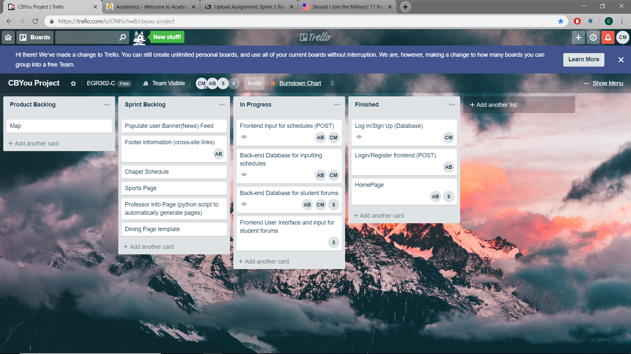

**Sprint 2 Retrospective**

# What went well:

1. The backend and frontend of the website work well together
2. The python script that reads events from inside CBU
3. Logo looks professional

# What did not go well (or improvements needed):

1. Pushing to Github did not work
2. Events were unorganized for user on homepage
3. Passwords were in plain text and caused security issues

# Action Items

1. Meet up more in person with teammates
2. Organize tasks
3. Create Back up Zip file

# Burndown Chart

[TODO: Insert Burndown Chart here]

**Team Evaluation**

# Write a short reflection after working with your team for the past 3 weeks, in particular describe how each member is contributing to the team. Then for each team member, assign a score from 0 – 100 and state why you have given that score.

Andrew Battles is contributing quite a bit to the project. He has done a large amount of the front end at the beginning of the project and has written a heavy python script for gathering events for the homepage. 100

Sunny is also contributing a fair amount to the project as well. He has mostly been working on the front end of things with the navbar one the home page and other elements of the website. He also designed the logo as well.